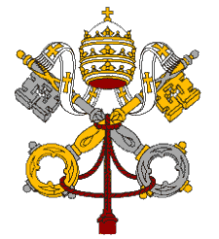
Statement by H.E. Archbishop Ivan Jurkovič, Permanent Representative of the Holy See to the United Nations and Other International Organizations in Geneva at the United Nations Human Rights Council - 26th Session of the Universal Periodic Review
Bolivarian Republic of Venezuela
1 November 2016

Mr. President,
The Delegation of the Holy See welcomes the Delegation of Venezuela during the presentation of its second Universal Periodic Review.
We acknowledge the positive steps taken by Venezuela, including the creation of a National Council for Human Rights and the approval of the 2015-2019 National Human Rights Plan. Also encouraging is the establishment of a National Commission for the Prevention of Torture and Other Cruel, Inhuman and Degrading Treatment.
My Delegation wishes to express its concern in relation to the current political and social situation and welcomes the decision to start a sincere dialogue among the concerned parties in the search for a solution to the present crisis.
We recommend to the Delegation of Venezuela the following brief considerations:

- To continue to exert all efforts for a peaceful resolution to the serious political tension, which is the source of a multitude of humanitarian and social concerns.
- To see that legitimate independence of public powers is respected in accordance with its international commitments.
- To continue efforts to combat criminal violence through the fair and transparent administration of justice, and to investigate and adjudicate all accusations of human rights violations, in particular regarding extra-judicial executions and the excessive use of force by civil authorities.

Thank you, Mr President.

